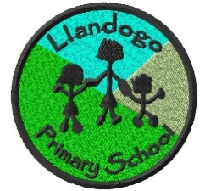
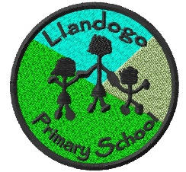
Dosbarth Cribyn -Reception
Autumn 1 Overview
Hello Everyone!!! Whether your child has previously been a pupil at the school or your child has just joined us for the first time in September, we would like to welcome you!!
As you can imagine this year has been very strange but its been wonderful seeing the way that the class has come together.
Looking to the future it’s impossible to know how this year will pan out with Covid19, but whether we are in school or online we can continue our learning together.
The aim of this letter is to give you some information about foundation which you may find helpful.
We have introduced Class Dojos as a reward system. Pupils are given dojo points for good work, manners, team work and a whole host of other positive behaviours.
There are two Teaching Assistants working in Foundation this year. These are Mrs Williams and Miss Szwagrzak.
Our main PE sessions will be Friday afternoons. Please ensure that your child is dressed for PE when they come to school that day. Children will have regular Forest school sessions throughout the year. To make this more manageable and more specific to a particular age group this will be on a rota basis. You will be informed when these sessions take place.
If you haven’t already done so please would you send in some water proof clothing for your child and some wellies. As you know we have a fabulous outdoor area and will be going outdoors in all weather!
Windows will be kept open during class times so please make sure your children have some warm clothes when the weather gets colder.
So now to the learning – Phonics teaching will be an important part of our school day. There will be a phonics session each day using the Read Write Inc scheme. Pupils will learn letter sounds and they will be taught to word build. Reading books will be given to children when they have a good knowledge of letter sounds and are able to blend sounds together.
The topic for this term is All About Me –Having discussed what the children would like to learn I have created the overview below – however this comes with the caveat that should the children want to explore other ideas and raise other questions we will adapt, tweak and change to respond to their suggestions.
To conclude this letter I have also included a “Home Learning Menu” for your children to select from and complete activities at home. These can then be uploaded to the SEESAW account where I can respond and allocate dojo points. There may be occasions where these can also be shared in class – the menu is only suggestions and is not a finite list – please encourage your child to discuss their ideas with you as I’m sure they can add even more to it. We would like your child to complete at least 2 pieces of home learning each half term however there is no limit to them – if they would like to run a home learning project each week that would be great to see!
As always, if you have any questions please do not hesitate to call/email the school and I will respond as quickly as possible.

All About Me – Class based learning
Foundation Phase – Reception
LLC:  - Personal news  - Hospital Role Play  - Home Corner | Maths & Numeracy:  - Counting  - Adding/Taking away  - One more/1 less  - Reciting numbers.  - Matching numbers
Science & Technology  - ICT / DCF: becoming familiar with Ipads and White board to enhance learning  - Our Senses | Health & Wellbeing  - Class Charter  - Introducing Values learning - RESPECT
Humanities  - Growth and change  - Differences and similarities between babies and children  - Where we live | Expressive Arts  - Portraits  - Drawings and painting of ourselves  - Drawing homes

Dosbarth Cribyn - All About Me
Home learning Menu

Other ideas that the children suggested:

- How different parts of our bodies works.
- Family Scrapbooks.
- Family Trees
- Different types of exercise and why exercise is good for us.

In addition there will also be reading. Phonics and writing tasks set.

I hope you find this letter useful. If you need any further information please don’t hesitate to contact me by emailing the school office.
Best Wishes
Adele Jarvis
Foundation Phase Teacher.

